The
Recruiting
Process

Blaze Football Recruiting Information

Traits college football coaches will evaluate: | How they perform these evaluations:
1. Football Ability and Potential | 1. Watching highlight and game film
2. Size, Speed and Strength and Potential | 2. Doing live evaluations at their school camps
3. Grades and ACT scores (or SAT scores) | 3. Talking to high school coaches
4. Citizenship | 4. THEY DON'T USE COMBINES OR RECRUITING SERVICES

How the process works:
1. Winter of junior year - colleges are provided with information about potential players like contact info, grades, realistic projection of where they could play, etc. Our coaches send this information out along with any highlight tapes and game film through Hudl.
2. Spring of junior year - coaches begin visiting with high school coaches to continue collecting information about players and to invite them to summer camps. Coaches may ask for transcripts and video, but are not allowed to meet with players. PLAYERS NEED TO FILL OUT FORM IN MAIN OFFICE TO RELEASE TRANSCRIPTS
3. Late spring of junior year - coaches will send players letters and camp information and might call during certain “open window” periods.
4. After your Junior year (or spring of Junior year) You need to be certified by the NCAA Eligibility Center to compete at an NCAA Division I or II school. Create a Certification Account and we'll guide you through the process. You need to create a Certification Account to make official visits to Divisions I and II schools or to sign a National Letter of Intent. Click here to create a certification account.
5. Summer of junior year - players may visit campuses as part of one day camps. Many of these camps will have coaches from several different colleges in attendance to evaluate players and talk with them.
6. Late summer of junior year - After evaluating video, transcripts, and conducting on-campus camp evaluations, scholarship schools will focus their attention on a few players that are qualified and meet their needs. This could include scholarship offers for the very best prospects, but it is not common.
7. Fall of senior year - coaches will stay in contact with players and may ask for additional game video
8. Late fall of senior year - most scholarship schools have offered all available scholarships and will be asking for final verbal commitments
9. After senior season - College coaches will begin visiting schools to talk with players face-to-face. They will gather transcripts, video and information from the head coach.
10. Winter of senior year - Division III schools will decide what players are qualified, meet their needs and begin calling the players for visits and commitments. Most of our players will fall under this category. ANY PLAYER ON OUR ROSTER CAN PLAY FOOTBALL AT MOST DIVISION III SCHOOLS. You may need to contact those schools and show interest as they often have small recruiting budgets and don’t get out to many schools in person.
10. Early February of senior year - Signing day for DI and DII players. Community colleges outside of Minnesota also have signings. There is always late movement because colleges offer more scholarships than are available.

What to do during sophomore and junior year.

- Meet with your counselor and begin looking into schools that: meet your career interests, meet your academic ability, are a good fit financially, and are a good fit for you personally. Plan to visit a few of those schools this summer. Visiting a campus is the best way to find that right fit.

2. Make a highlight video on Hudl. It's very easy to create them. We can send out your highlight tape and game film to any coach with an email address. Give Coach Krebs the emails of all possible coaches.
3. Keep working out to become bigger, faster and stronger in preparation for the fall season. Our strength program is the best way to get ready for college football. We would like all of our athletes to be involved in a winter and spring sport as long as those sports use our weight room.

4. Try to attend a “One Day” College Evaluation Football Camp this summer. Most of these camps are affordable, open to all interested players, have coaches from multiple schools in attendance, and will give college coaches a better idea of your abilities.

5. Keep up your grades in the classroom. We have student-athletes every year who have few school options because they can't qualify for certain colleges because of their grades.

6. Go to the annual MFCA Recruiting Combine (usually at end of April) – this is where all of the area colleges go to see you workout (be sure to be working in the off-season so you can time well in the 3 cone drill, shuttle, 40 yd dash, etc.)
7. After your Junior year (or spring of Junior year) You need to be certified by the NCAA Eligibility Center to compete at an NCAA Division I or II school. Create a Certification Account and we'll guide you through the process. You need to create a Certification Account to make official visits to Divisions I and II schools or to sign a National Letter of Intent. Click here to create a certification account.

NCAA Football Bowl Subdivision (FBS)
How many schools: There are 120 schools competing in the FBS (formerly Division I-A), the highest level in the collegiate ranks. This includes the big programs like Minnesota, USC and Notre Dame.
Scholarship count: FBS programs are allowed 85 scholarships on its roster at any given time, and generally can sign up to 25 players per year.
Scholarship breakdown: All 85 scholarships are full rides. There are no partial scholarships given in FBS football.

NCAA Football Championship Subdivision (FCS)
How Many Schools: There are 125 schools competing in the FCS (formerly Division I-AA) in 2008. This includes all of the Ivy League schools and FCS powers like North Dakota State and Northern Iowa.
Scholarship Count: FCS schools have 63 scholarships to be distributed, and up to 30 incoming players each year can be given aid.
Scholarship Breakdown: Scholarships at FCS schools can be full or partial rides. The 63 grants can be divided up in any way, but no more than 85 players can be put on scholarship.

NCAA Division II
How Many Schools: There are 156 schools competing in NCAA Division II. Some of the more well-known Division II football programs include St. Cloud State and University of Minnesota-Duluth.
Scholarship Count: Division II programs have 36 scholarships to be distributed, though some conferences don't allow their schools to have that many.
Scholarship Breakdown: Football scholarships at Division-II institutions can be divided among as many players as a program wishes. Most Division-II players are on partial scholarships.

NCAA Division III
How Many Schools: There are 239 schools playing Division III football in 2008. This includes schools like St. Thomas, Gustavus, University of Wisconsin-Eau Claire, etc.
Scholarship Count: There are no athletic scholarships in Division III athletics.
Scholarship Breakdown: Though there's no chance of getting a football scholarship at a Division III school, it is possible to receive an academic scholarship or a need-based grant that can help financially while you play football.

NAIA
How Many Schools: There are 92 schools that play football in the NAIA. There aren't any NAIA schools in Minnesota, but there are several in neighboring states.
Scholarship Count: NAIA football programs are permitted 24 scholarships to be spread out in any way.
Scholarship Breakdown: Partial scholarships are common. Strong students meeting a certain academic criteria can receive aid without it counting toward the 24-scholarship limit.

NJCAA
How Many Schools: There are 68 schools that participate in junior-college football nationwide and 10 in Minnesota. Minnesota schools like RCTC and Brainerd don't offer athletic scholarships. Neighboring states like North Dakota State College of Science can provide athletic scholarships.
Scholarship Count: NJCAA programs are permitted 85 scholarships.
Scholarship Breakdown: Many states, like Kansas, Texas and Mississippi, require its junior colleges to reserve a large number of space on the active roster for in-state talent. Kansas jucos, for example, must have 43 Kansas high school players on their roster.

THE RECRUITING PROCESS
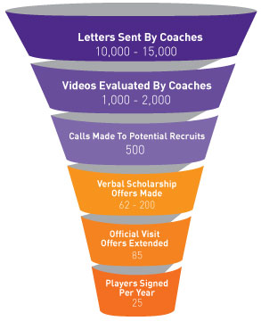
College coaches are looking for the best athletes they can find. So, they reach out to a lot of them, talk to a few, and eventually offer scholarships to just a small fraction. This is known as the recruiting funnel.
Coaches start with a huge sample of recruits but narrow their scholarship offers down to very few. Even a phone call is no guarantee. Roughly 1 in 20 athletes that receive a phone call from a coach ever play for that coach.
That’s why understanding the funnel and knowing what you can do to make sure you stay in it greatly increase your chances of landing an athletic scholarship. You have to realize that nothing in the recruiting process is handed to you. But, just like on the playing field or court, hard work and determination can provide a big payoff.

How do you survive the funnel? Remember these key points.
- Realize that the recruiting process is a two-way street. It’s not just about coaches getting in touch with you, you also have to reach out to them. Make phone call and send letters and emails to coaches you want to play for. Coaches want athletes who take initiative.
- Stay humble. Remember that there are thousands of other athletes out there that are just as good or better than you. Make it a point to work harder than other athletes during the recruiting process.
An Example of the Recruiting Funnel in Football
- A college football coaching staff sends out 10,000 to 15,000 letters and they watch 1,000 to 2,000 videos.
- They make only 500 phone calls to potential recruits.
- They verbally offer between 65 and 200 scholarships and extend up to 85 offers for official visits.
- They finally only sign a maximum of 25 players each year.

UNDERSTANDING YOUR LEVEL OF RECRUITMENT
According to the NCAA, less than 2% of high school athletes earn college athletic scholarships. It’s important to gauge the level of attention that you’re receiving from college coaches so that you know what to expect from the recruiting process.
There are several levels of recruitment. See where you stand in the list below, and find out from NCSA the best way to move up a level or two and improve your chances of earning an athletic scholarship.

Heavily Recruited athletes are top-tier recruits who will likely go on to compete at the Division I level. The recruiting process for these high-level athletes is outlined below.
- Freshmen – At least one scholarship offer. Receive an abundance of letters from coaches, questionnaires, camp invites and admissions information, and generous amounts of letters asking you to call or email.
- Sophomores – Several scholarship offers and unofficial visit invites. Overflow of letters and evaluation at high school games and summer tournaments.
- Juniors – 10 or more scholarship offers and 10 or more unofficial visits. Pre-evaluation from admissions. Multiple calls from coaches in April, May, June and July and asks for a verbal commitment.
- Seniors – National Letter of Intent signing during the early signing period.

Seriously Recruited athletes are high-level recruits who will certainly play sports at the college level.
- Freshmen – Receive a fair amount of letters from coaches, questionnaires, camp Invites and admissions information, and some letters asking you to call or email.
- Sophomores – At least one scholarship offer. Abundance of letters, questionnaires and letters inviting you to call or email. Evaluation at high school games and summer tournaments.
- Juniors – 5 or more scholarship offers and 5 or more unofficial visits. Handwritten letters from coaches. Pre-evaluation from admissions. A few calls in April, May, June and July.
- Seniors – 10 or more offers and at least one official visit. In-home visits.

Moderately Recruited athletes may not end up at the Division I level, but there’s a good chance that they’ll find the right fit at Division II or Division III.
- Freshmen – Some letters and questionnaires from coaches, a few camp invites and some admissions information.
- Sophomores – A generous amount of letters, camp invites, admissions information, and questionnaires.
- Juniors – A few scholarship offers. A few handwritten letters and some calls in April, May, June and July. Evaluation at summer tournaments.
- Seniors – Less than 10 scholarship offers and less than 10 official visit invites. Pre-evaluation from admissions.

Lightly Recruited athletes need to draw more attention to themselves if they want to earn scholarship offers.
- Freshmen – A few letters from coaches and a few camp brochures.
- Sophomores – Several letters from coaches. Some camp invites, admissions info and questionnaires.
- Juniors – A couple of handwritten letters and a few questionnaires. A few evaluations at summer tournaments.
- Seniors – 3 or more offers and 3 or more official invites. Some unofficial invites and some invitations to walk-on.

Not Recruited athletes aren’t on the radar either because they haven’t reached out to college coaches, or they don’t realistically have the athletic ability to play at the collegiate level.
- Freshmen – No recruiting materials.
- Sophomores – A few camp brochures.
- Juniors – Some camp invites, admissions information and questionnaires.
- Seniors – Camp and tryout invite, admissions packets and unofficial visit offers only.

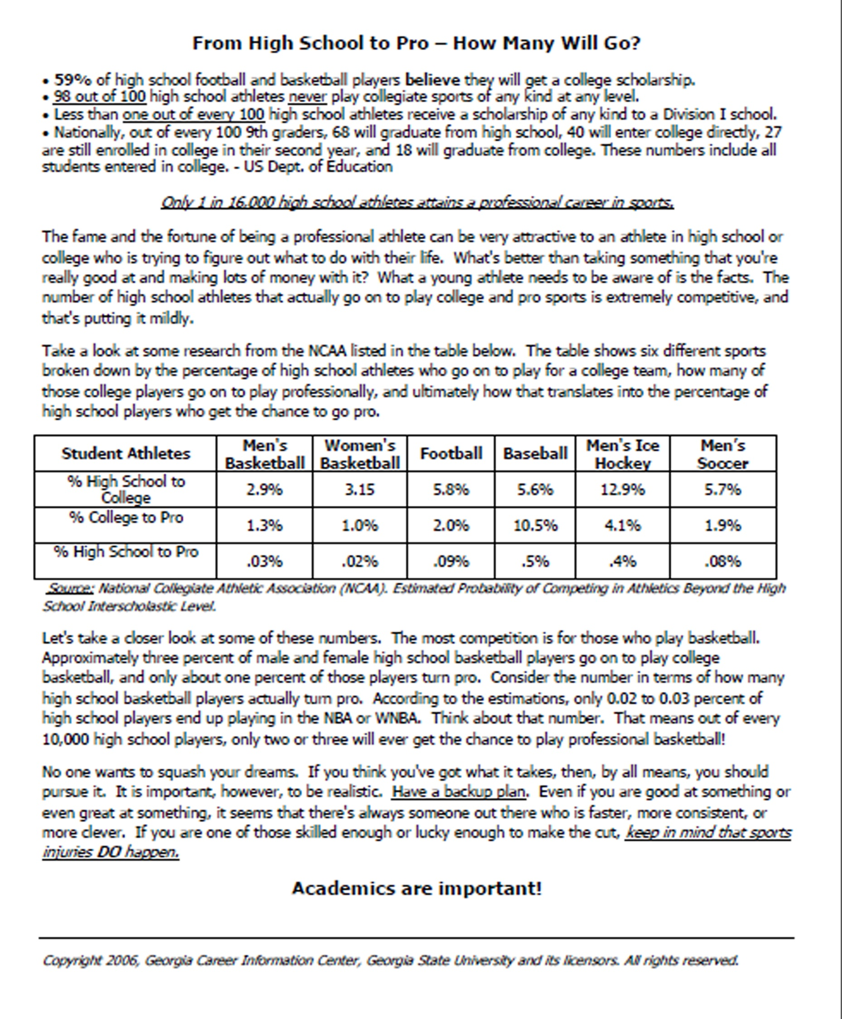
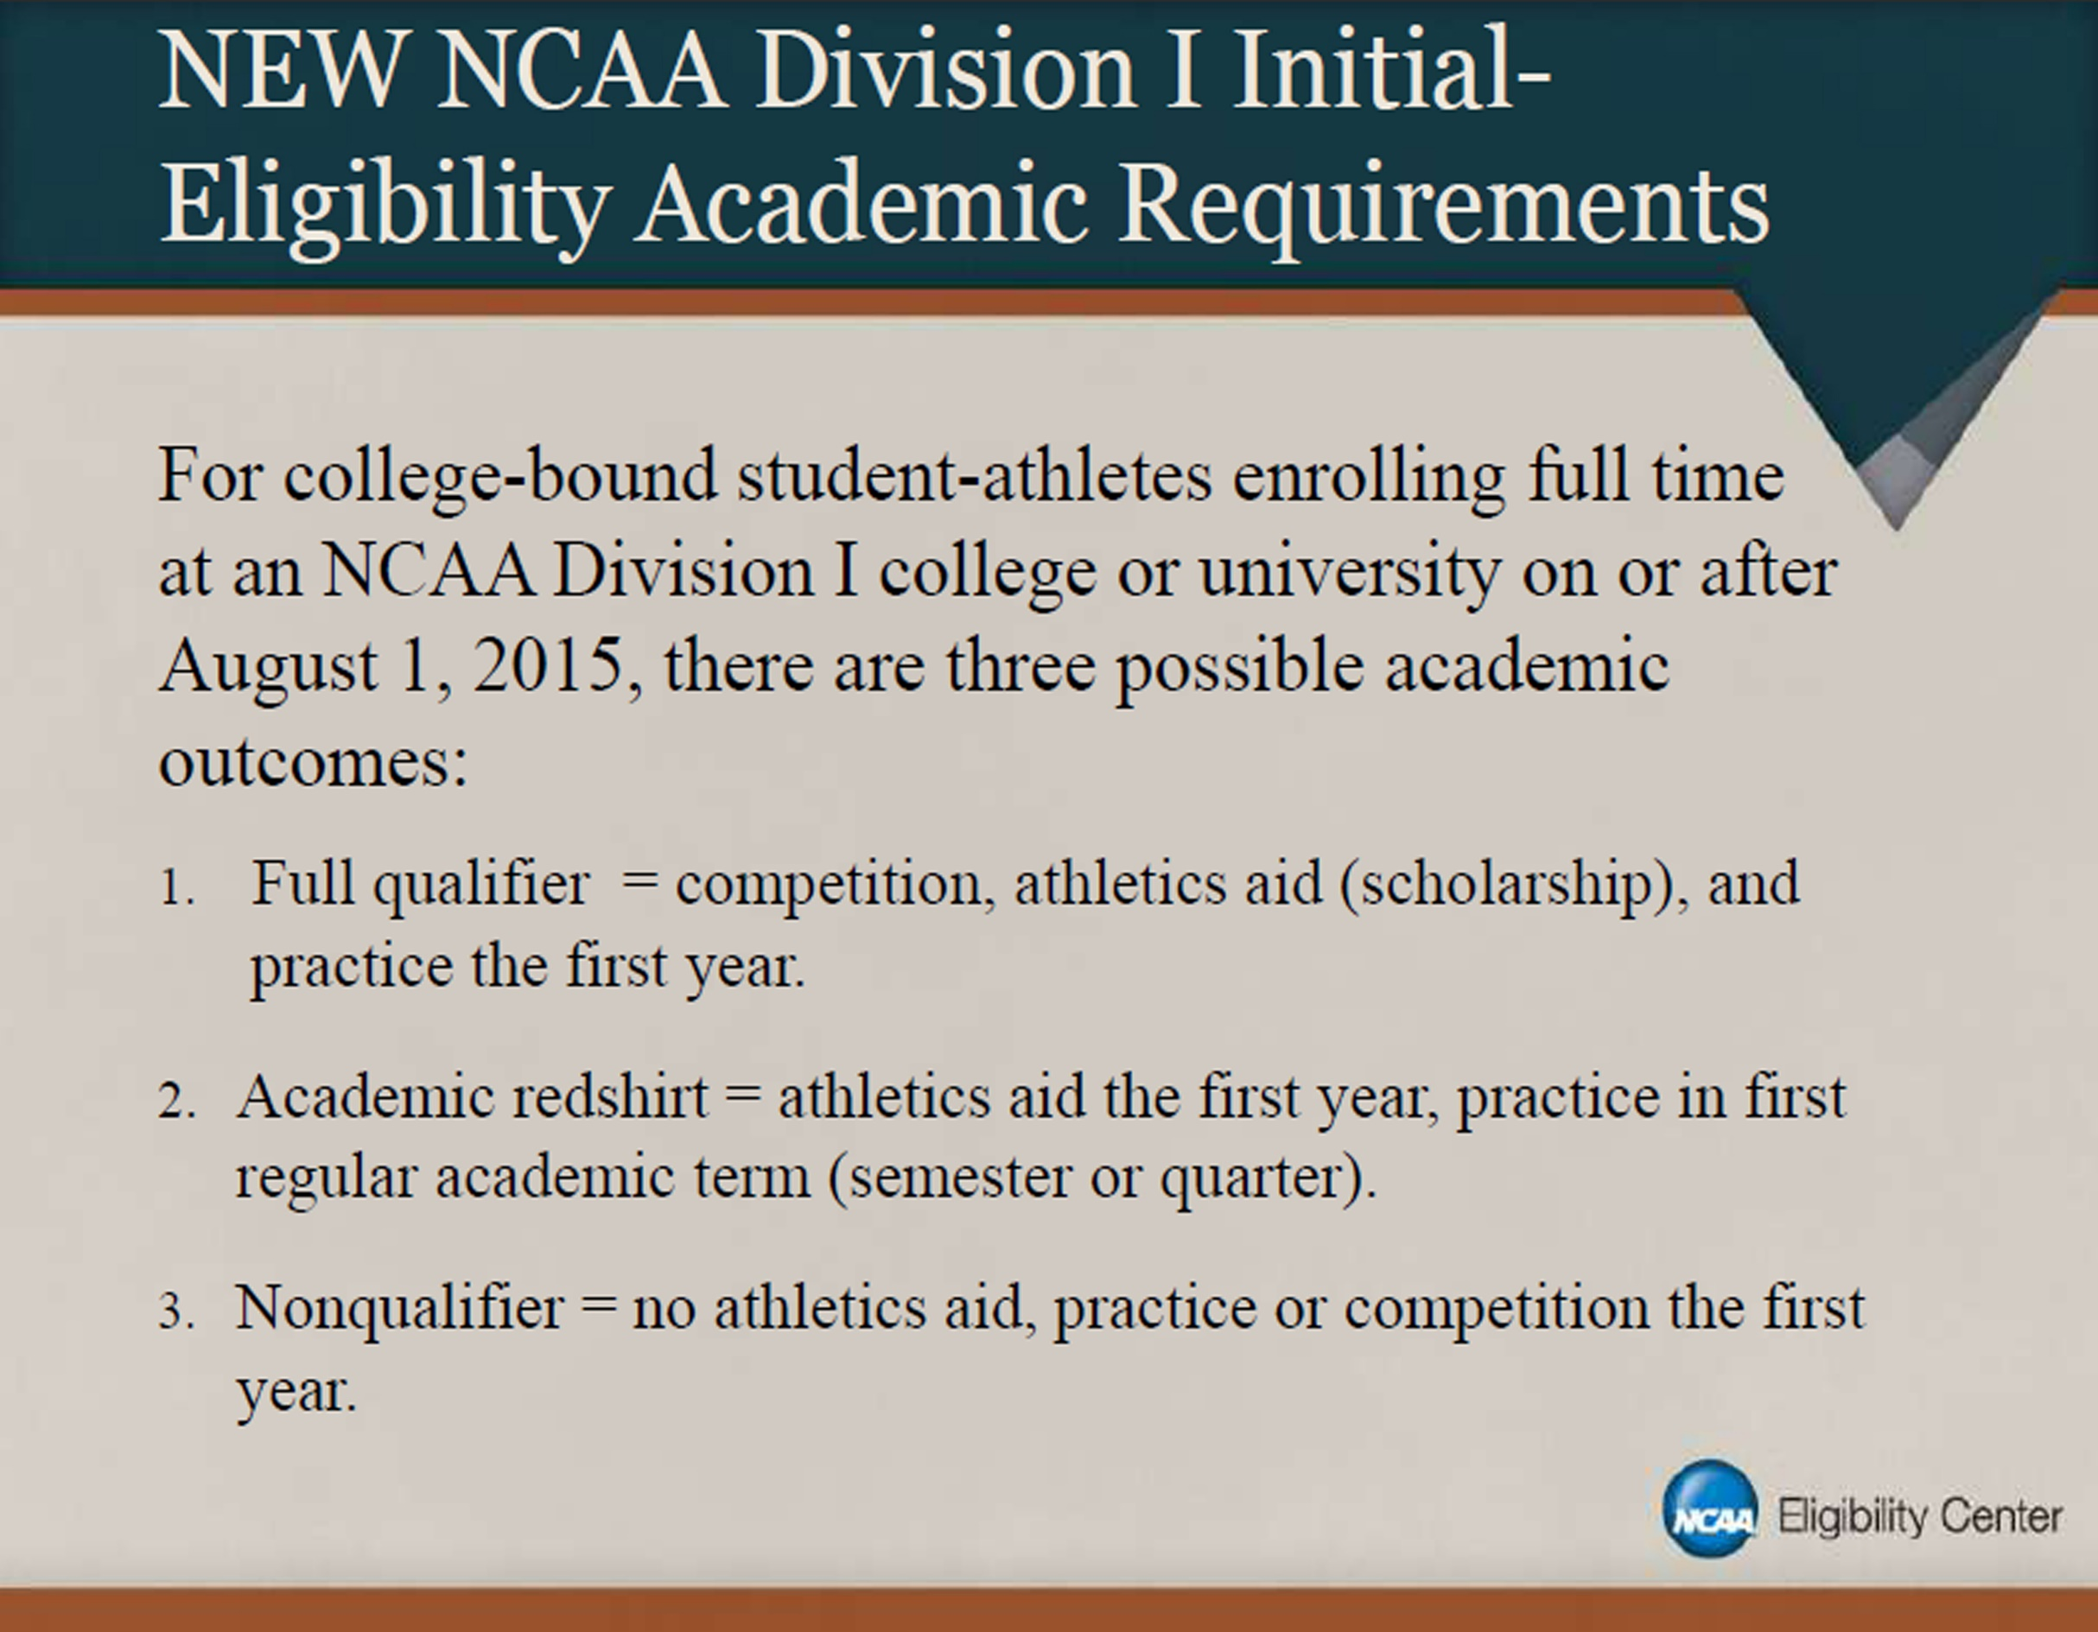
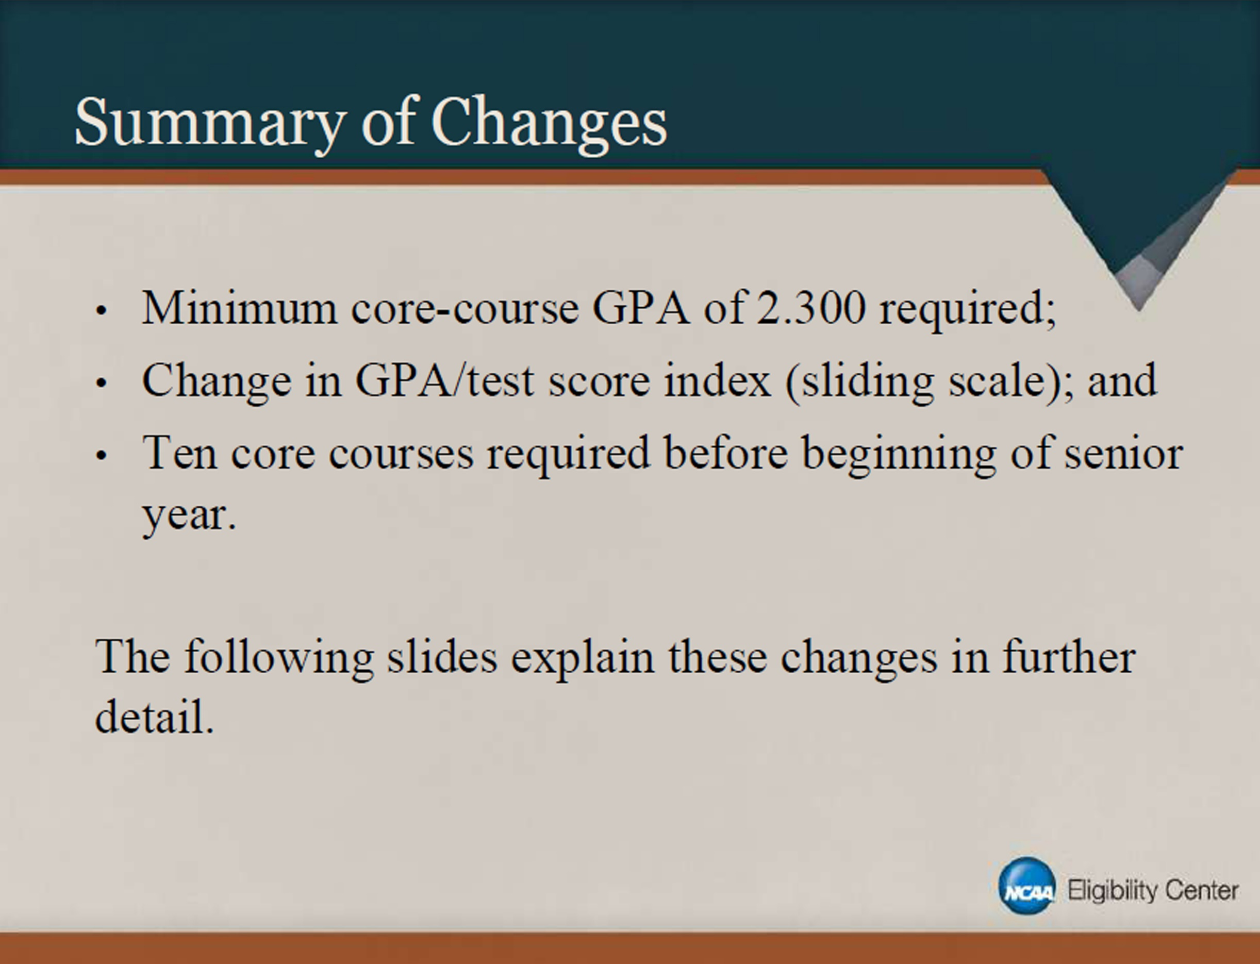
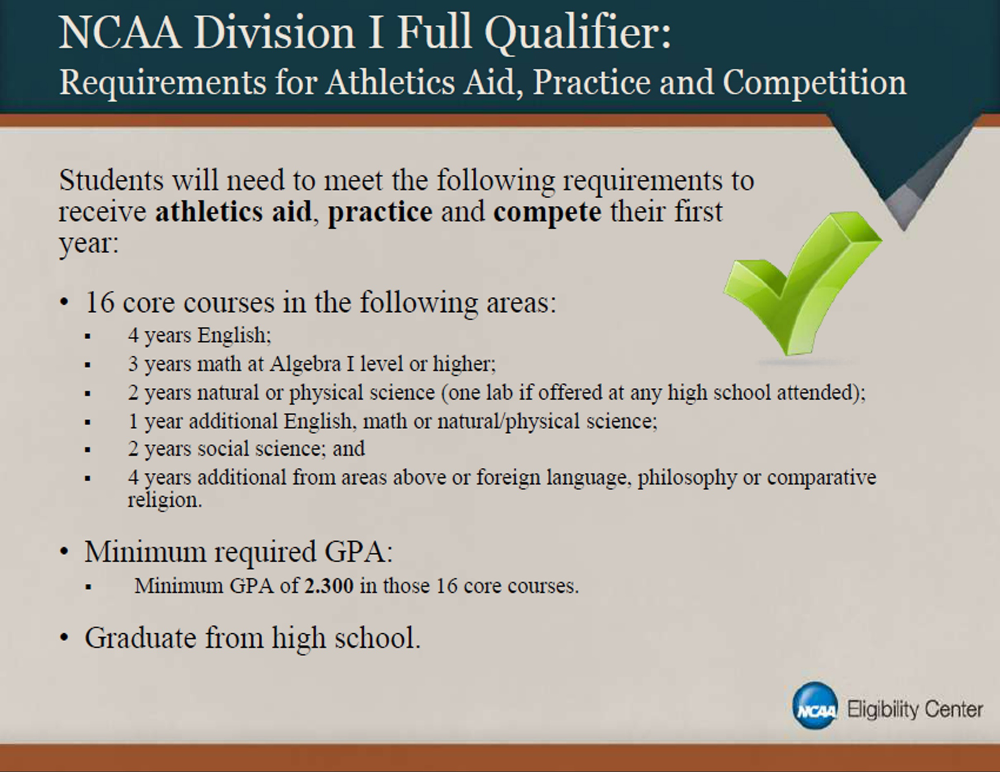
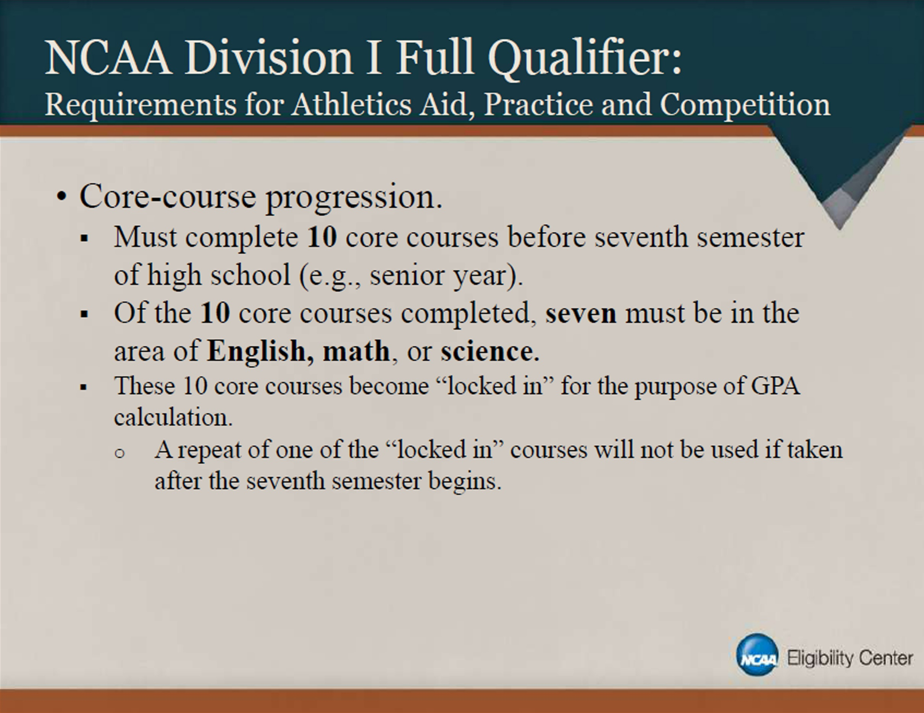
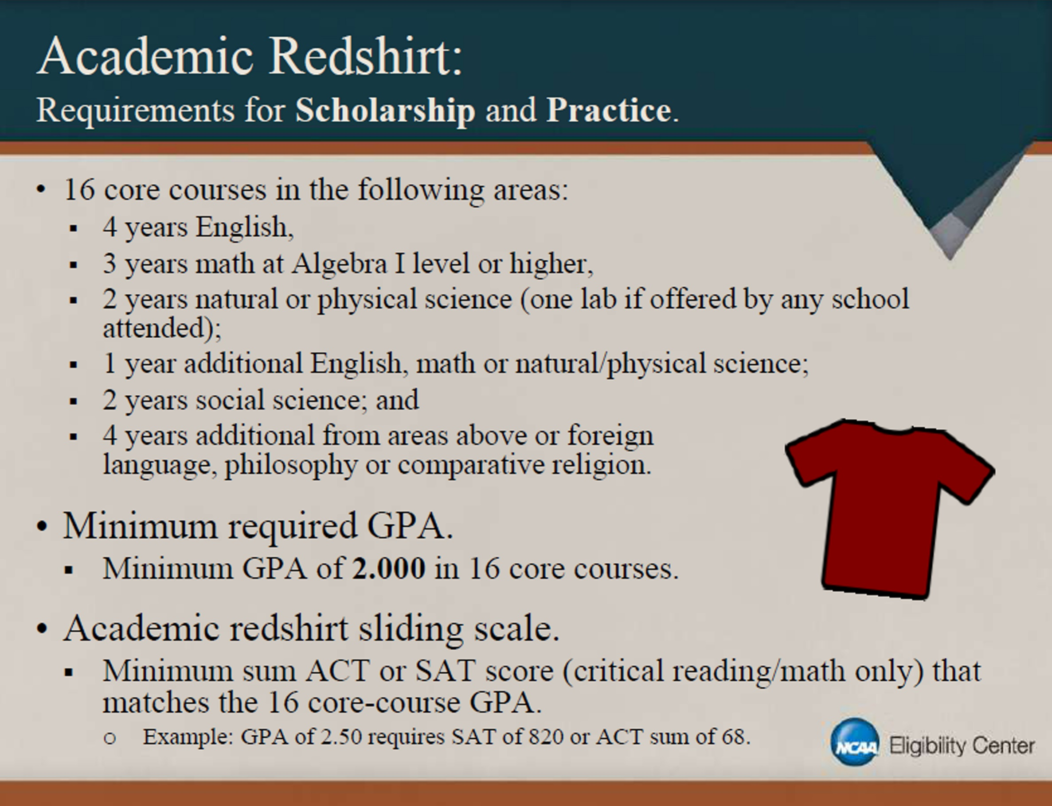

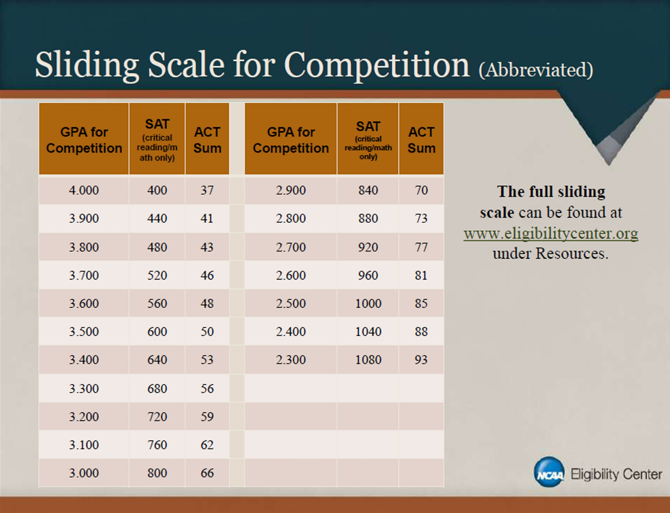

- Home
- Student-Athletes
- Future

Test Scores
When you register for the SAT or ACT, use the NCAA Eligibility Center code of 9999 so your scores are sent directly to the Eligibility Center from the testing agency. Test scores on transcripts will not be used in your academic certification.
A combined SAT score is calculated by adding reading and math subscores. An ACT sum score is calculated by adding English, math, reading and science subscores. You may take the SAT or ACT an unlimited number of times before you enroll full-time in college. If you take either test more than once, the best sub score from different tests are used to meet initial eligibility requirements.
If you take the current SAT before March 2016 and then take the redesigned SAT at a later date, the NCAA Eligibility Center will not combine section scores from the current and redesigned SAT when determining your initial eligibility. The NCAA Eligibility Center will only combine section scores from the same version of the test. Because the redesigned SAT varies in design and measures different academic concepts than the old SAT, the Eligibility Center will apply College Board’s concordance tables when performing academic certifications for students with redesigned SAT scores
- SAT Score Procedures
If you take the SAT or ACT test after you graduate high school, the NCAA Eligibility Center may ask you to confirm that you have not yet enrolled full-time in college, by completing and submitting a student matriculation letter.
- Download a student matriculation letter

Division I test score requirements
Division I uses a sliding scale to match SAT/ACT scores and core-course grade-point averages to determine eligibility. The sliding scale balances your test score with your GPA. If you have a low test score, you need a higher GPA to be eligible. If you have a low GPA, you need a higher test score to be eligible.
Learn more about Division I academic requirements
Core GPA | SAT | ACT
3.550  & above | 400 | 37
3.525 | 410 | 38
3.500 | 420 | 39
3.475 | 430 | 40
3.450 | 440 | 41
3.425 | 450 | 41
3.400 | 460 | 42
3.375 | 470 | 42
3.350 | 480 | 43
3.325 | 490 | 44
3.300 | 500 | 44
3.275 | 510 | 45
3.250 | 520 | 46
3.225 | 530 | 46
3.200 | 540 | 47
3.175 | 550 | 47
3.150 | 560 | 48
3.125 | 570 | 49
3.100 | 580 | 49
3.075 | 590 | 50
3.050 | 600 | 50
3.025 | 610 | 51
3.000 | 620 | 52
2.975 | 630 | 52
2.950 | 640 | 53
2.925 | 650 | 53
2.900 | 660 | 54
2.875 | 670 | 55
2.850 | 680 | 56
2.825 | 690 | 56
2.800 | 700 | 57
2.775 | 710 | 58
2.750 | 720 | 59
2.725 | 730 | 60
2.700 | 740 | 61
2.675 | 750 | 61
2.650 | 760 | 62
2.625 | 770 | 63
2.600 | 780 | 64
2.575 | 790 | 65
2.550 | 800 | 66
2.525 | 810 | 67
2.500 | 820 | 68
2.475 | 830 | 69
2.450 | 840 | 70
2.425 | 850 | 70
2.400 | 860 | 71
2.375 | 870 | 72
2.350 | 880 | 73
2.325 | 890 | 74
GPA's Below 2.3 Are Redshirt only
2.300 | 900 | 75
2.299 | 910 | 76
2.275 | 910 | 76
2.250 | 920 | 77
2.225 | 930 | 78
2.200 | 940 | 79
2.175 | 950 | 80
2.150 | 960 | 81
2.125 | 970 | 82
2.100 | 980 | 83
2.075 | 990 | 84
2.050 | 1000 | 85
2.025 | 1010 | 86
2.000 | 1020 | 86

Division II test score requirements
If you enroll full-time at a Division II school before Aug. 1, 2018, you must meet all academic requirements and earn at least a combined SAT score of 820 or an ACT sum score of 68 to be eligible to compete. Remember, if you took the SAT on or after March 2016 you need to compare your score on the College Board concordance table. The 820 score is after the concordance table is applied.
If you enroll full-time at a Division II school after Aug. 1, 2018, you must meet all academic requirements and earn an SAT or ACT score matching your core-course GPA on the Division II sliding scale to be eligible to compete. The sliding scale will balance your test score with your GPA. If you have a low test score, you need a higher GPA to be eligible. If you have a low GPA, you need a higher test score to be eligible.
Learn more about Division II academic requirements
If you enroll full-time at a Division II school after Aug. 1, 2018, and you have not met all the Division II academic requirements, you may not compete in your first year. If you meet the requirements to be a partial qualifier, you may practice and receive an athletics scholarship in your first year. To be a partial qualifier, you must graduate high school and meet ALL the following requirements:
- Complete 16 core courses.
- Earn at least a 2.0 GPA in your core courses.
- Earn an SAT or ACT score matching your core-course GPA on the Division II sliding scale.
Use for Division II FULL QUALIFIERAfter August 1, 2018 |  |  | Use for Division II PARTIAL QUALIFIER after August 1, 2018
Core GPA | SAT | ACT | Core GPA | SAT | ACT
3.300 & above | 400 | 37 | 3.050 & above | 400 | 37
3.275 | 410 | 38 | 3.025 | 410 | 38
3.250 | 420 | 39 | 3.000 | 420 | 39
3.225 | 430 | 40 | 2.975 | 430 | 40
3.200 | 440 | 41 | 2.950 | 440 | 41
3.175 | 450 | 41 | 2.925 | 450 | 41
3.150 | 460 | 42 | 2.900 | 460 | 42
3.125 | 470 | 42 | 2.875 | 470 | 42
3.100 | 480 | 43 | 2.850 | 480 | 43
3.075 | 490 | 44 | 2.825 | 490 | 44
3.050 | 500 | 44 | 2.800 | 500 | 44
3.025 | 510 | 45 | 2.775 | 510 | 45
3.000 | 520 | 46 | 2.750 | 520 | 46
2.975 | 530 | 46 | 2.725 | 530 | 46
2.950 | 540 | 47 | 2.700 | 540 | 47
2.925 | 550 | 47 | 2.675 | 550 | 47
2.900 | 560 | 48 | 2.650 | 560 | 48
2.875 | 570 | 49 | 2.625 | 570 | 49
2.850 | 580 | 49 | 2.600 | 580 | 49
2.825 | 590 | 50 | 2.575 | 590 | 50
2.800 | 600 | 50 | 2.550 | 600 | 50
2.775 | 610 | 51 | 2.525 | 610 | 51
2.750 | 620 | 52 | 2.500 | 620 | 52
2.725 | 630 | 52 | 2.475 | 630 | 52
2.700 | 640 | 53 | 2.450 | 640 | 53
2.675 | 650 | 53 | 2.425 | 650 | 53
2.650 | 660 | 54 | 2.400 | 660 | 54
2.625 | 670 | 55 | 2.375 | 670 | 55
2.600 | 680 | 56 | 2.350 | 680 | 56
2.575 | 690 | 56 | 2.325 | 690 | 56
2.550 | 700 | 57 | 2.300 | 700 | 57
2.525 | 710 | 58 | 2.275 | 710 | 58
2.500 | 720 | 59 | 2.250 | 720 | 59
2.475 | 730 | 59 | 2.225 | 730 | 60
2.450 | 740 | 60 | 2.200 | 740 | 61
2.425 | 750 | 61 | 2.175 | 750 | 61
2.400 | 760 | 62 | 2.150 | 760 | 62
2.375 | 770 | 63 | 2.125 | 770 | 63
2.350 | 780 | 64 | 2.100 | 780 | 64
2.325 | 790 | 65 | 2.075 | 790 | 65
2.300 | 800 | 66 | 2.050 | 800 | 66
2.275 | 810 | 67 | 2.025 | 810 | 67
2.250 | 820 | 68 | 2.000 | 820 & above | 68 & above
2.225 | 830 | 69
2.200 | 840 & above | 70 & above

- Future

Eligibility Standards
- Play Division I Sports
- Play Division II Sports

Student-Athlete Pages
- Want To Play College Sports?
- Amateurism
- Choosing a College
- Core Courses
- Education-Impacting Disabilities
- Educational Resources
- Grade-Point Average
- Home School Students
- How to Register
- International Student-Athletes
- National Letter of Intent
- Nontraditional Courses
- Recruiting
- Scholarships
- Test Scores

Eligibility Toolkit
- Initial-Eligibility Brochure
- Division I Initial-Eligibility Quick Reference Sheet
- Division II Initial-Eligibility Quick Reference Sheet
- Division II Initial-Eligibility Quick Reference Sheet (Current)
- Guide for the College-Bound Student-Athlete
- 2.3 or Take a Knee

NCAA Resources
- NCAA Sports
- Search for a School
- Recruiting Fact Sheet
- Health and Safety
- Sexual Violence Prevention Tool Kit

College Recruiting Tips

Recruiting services cost money
We are a big school, great training no need for personal trainer, we train u how colleges train

Choose 25-50 schools to email to coaches at ur position
I have list of hundreds of emails i send prospect info to on ur behalf with hudl link (u need to create highlight on hudl for yourself)
See who contacts you the most via phone and text

Emails and mailings mean nothing
If they want you they will call and come to your school to meet you
Texting is good also but they can mass text so not as good as a call

Colleges start with several thousand names then start to make their list smaller after they see your film and see you in person.

You need the following to qualify for college: Click here also see quick reference below:

For more information, visit www.eligibilitycenter.org or www.2point3.org.

Your core-course GPA is the average of your best grades achieved for all required core courses (this is different and usually lower than your cumulative GPA). If you have taken extra core courses, those courses will be used in your GPA, only if they improve your GPA. You can use this core-course worksheet to help.

Its ok to walk on if you can afford it. It’s a great opportunity to get a chance to play college ball and scholarships are sometimes awarded to those who end up contributing with significant playing time.

D2 schools don’t give full scholarships, mostly partial 2-5000 dollars. D3 schools don’t give any athletic scholarships so you would need high GPA (3.5 and above) to have a chance at academic award money. Grants and financial aid may be available if you apply for those individually.

